Finance Contact Details:
Finance Service Team (FST):
Engineering | FinServ.Engineering@unsw.edu.au
Medicine | FinServ.Medicine@unsw.edu.au
Science | FinServ.Science@unsw.edu.au
UNSW Canberra | finance@adfa.edu.au  T : 02 5114 5243
Finance Help Desk | financehelp@unsw.edu.au

Selection for manual intervention in Jaggaer:
Q. What is for functionality of the manual intervention in Jaggaer CIM?
A. Manual intervention is used for freight or a Jaggaer user wants the FST/Fin Help to intervene with the PO before it is dispatched to the supplier.
A jaggaer user can request for the following; delivery address change outside the university, email a copy of the PO to the user or split the cost of PO between two cost centres.
Q. How do Jaggaer users pass along information/details for the manual intervention to FST/Fin Help Desk?
A. The internal comment field in Jaggaer can be used to communicate the reason for the manual intervention to FST/Fin Help Desk. Please separate line items from the shopping cart which do not need manual intervention as this will delay line items processing.
For Status of Shopping Cart/Requisition/Purchase Order (PO)
Q. Where can I check my shopping Cart/Requisition/Purchase Order status in Jaggaer?
A. The “view my request” functionality allows users to check their Shopping Cart/Requisition/Purchase Order status.
Q. What do the status indicate?
A.
Status | Description | Who to contact for assistance?
Pending Approval | Requisition submitted requires safety or cost centre approval | Safety officer or lab manager
New | Requisition submitted ready for uploading to NSF
Sent to Purchasing | Requisition has been sent for processing within the finance system | Contact FST/Fin Help Desk with requisition number
Ordered (PO linked to Jaggaer requisition) | Requisition has been processed into Purchase Order and dispatched to the supplier | Contact FST and Supplier with PO number i.e JAGER.XXXXXXXXXX
Received | Requisition /PO has been received in Jaggaer
Cancelled | Requisition/PO is cancelled by NSF or user in Jaggaer

Q. Where can I find the requisition and PO number for my shopping cart?
A. This information can be viewed from the information icon in the “view my requisition.”
Header detail Request #
Item details Purchase order (only available for the status of “ordered”)
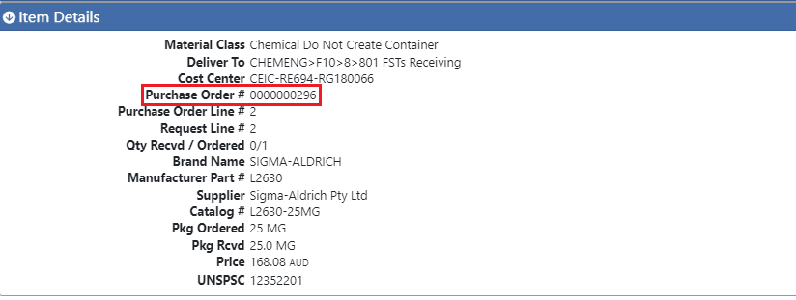
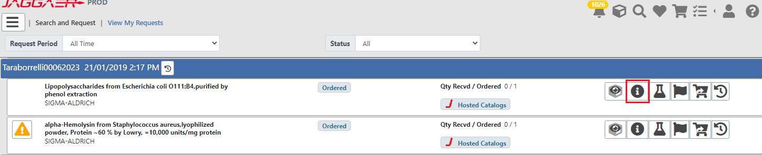

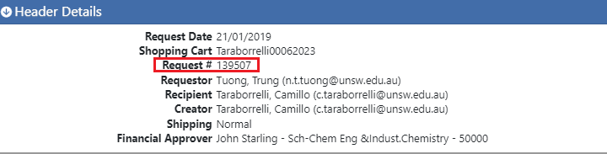

For Cancellation of Shopping Cart/Requisition/PO
Q. How do I do cancel Shopping Cart/Requisition/PO?
A. The status of the Shopping Cart/Requisition/PO will dictate how and who can cancel the Shopping Cart/Requisition/PO.
Cancellation Process
Check the status of the Shopping Cart/Requisition/PO in the “view my request” functionality
Status | Who to contact for cancellation? | Contact details | Requirements
Held Cart | Safety approver (School manager, lab manager or local Safety officers) | Local School contacts | Email local school contact with the shopping cart or requisition number to be cancelled/rejected in Jaggaer. Cancellation/rejection needs to take place daily before 9 pm
New | Lab managers or School Managers | Local School contacts | Email local school contact with the shopping cart or requisition number to be cancelled in Jaggaer. Cancellation needs to take place daily before 9 pm.
Sent to Purchasing | Fin Help Desk |  | Email Fin Help desk the requisition number to be cancelled.
Ordered | Fin Help Desk and Supplier |  | Email Fin Help desk and the supplier with the PO number to be cancelled.

Receiving PO in Jaggaer.
Q. Do users need to receive PO in Jaggaer?
A. Yes, all line items ordered in Jaggaer will need to be received by Jaggaer to initiate the invoice payment process.
Q. How does the user receive a PO in Jaggaer?
A. Please follow the guide for receiving in Jaggaer (link)
Q. What to do when the PO is received in Jaggaer and an email from FST/Fin Help Desk/Account payable is received?
A. Please request that FST/Fin Help Desk/Account payable to received PO manually in NSF.

